September 9, 09/09

Normal equation:
- Inversion kese nikalte he, matrix ka inverse nikle ye jaruri nahi he.
- Har baar ye isliye nahi hoti coz inverse nikalna costly he.
- Inverse pr baad me kaam krege

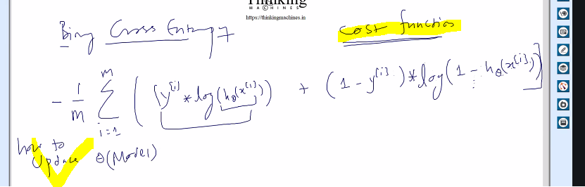
Iska derivative nikalna.

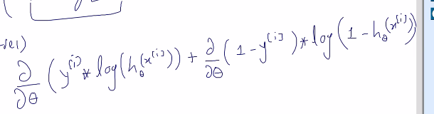

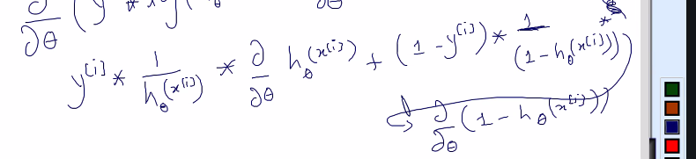
Chain rule : logx ka nikala to 1/x and logx me x tha to d/dx of x bhi lgaeah
d/dx logx = 1/x* d/dx(x)

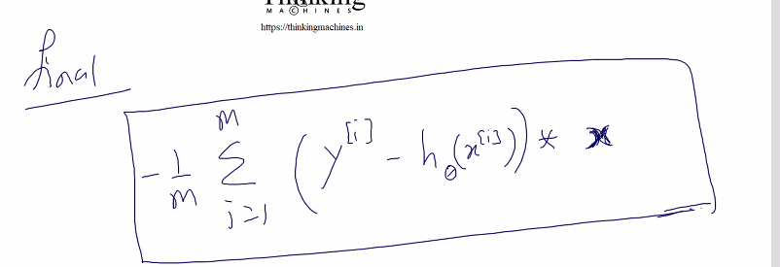

Ab or chahiye logistic regression k liya: kuch bhi nahi chahiye
Infra bna hua he kuch required chize bnani pdegi.

Ab naya topic: Computational graph
[Neural cnl in sb me jarurat pdegi.]
Imp: rules ki book hath me rkhni pdegi.
Ek function
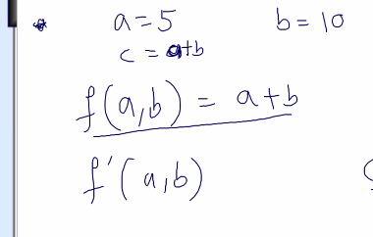
Iska graph esa bnega
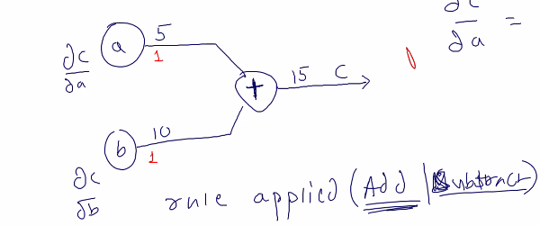
Ab humko
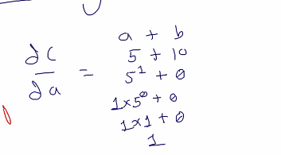
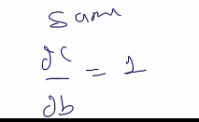

Dc/da= 1 meand 5 ko mene change kiya like add 3 to c me kya change aayega?
Jo change kiya uska result of dc/da = 1 se multiply means 3*1=3 to c=15+3= 18 ho jayega.
Same for b
And parallel me chane nahi hoaga ek k bad ek hoga.
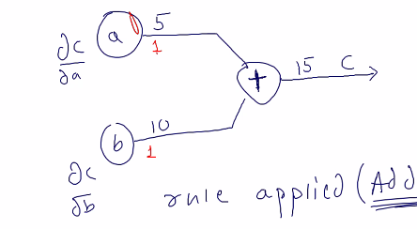

Another function:
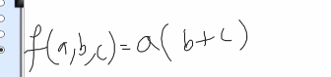
Iska graph draw krna he
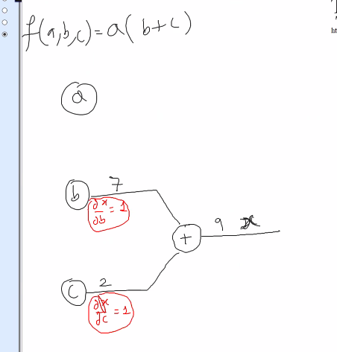
Here x depends on b and c
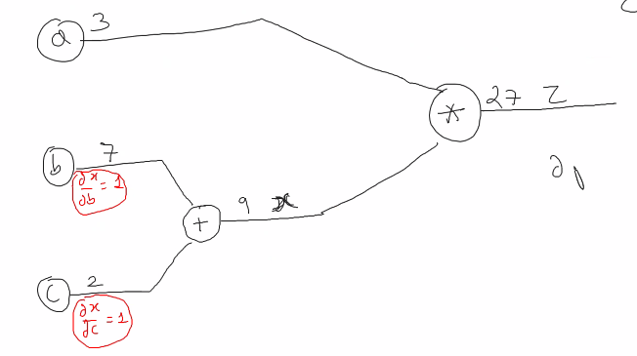
Final result ko Z se annotate kiya.
Z ka derivative bngega har k respect me like, kyuki z depends on a ,b,c
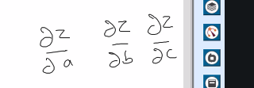

Phle outer wala compurte:
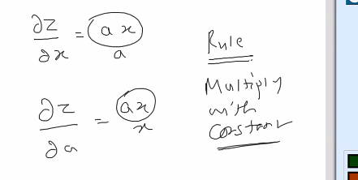
Ab z ka b k respect me

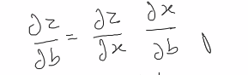

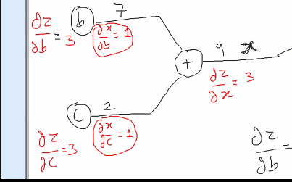
To z/b=3 and z/c=3 aaya
Ab maan lo b=7 he and b ko 13 kiya to z me 3*6= 18 ka change aayega.

Final ss:
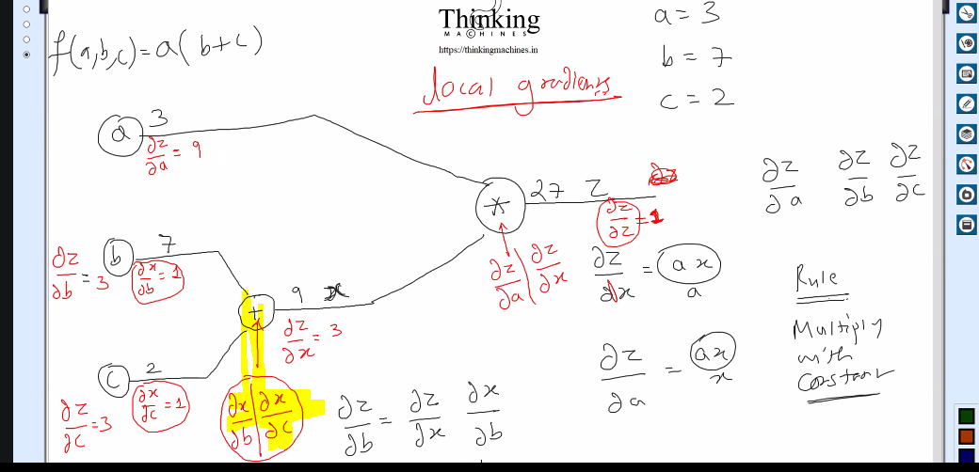
Next function:
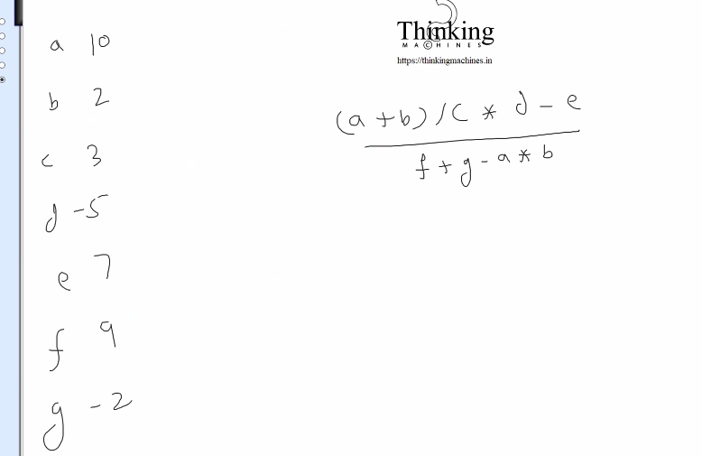
Is pr workout krna he
Logistic humko krna he, phir baat aayegi multiclass ki, and neural network
To next lecture se theory chlegi neural network ki and humko logistic wala krna he.

